**Prerequisites for Developing on AEM**

You will need the following skills for developing on top of AEM:

* Basic knowledge of web application techniques, including:
  + the request -response (XMLHttpRequest / XMLHttpResponse) cycle
  + HTML
  + CSS
  + JavaScript
* Working knowledge of the Experience Server (CRX), including the Content Explorer
* For developing in the classic UI, basic knowledge of JSP (JavaServer Pages) including the ability to understand and modify simple JSP examples is also required.

## Java Content Repository

The Java Content Repository (JCR) standard, [JSR 283](http://www.day.com/specs/jcr/2.0/), specifies a vendor-independent and implementation-independent way to access content bi-directionally on a granular level within a content repository.

Specification lead is held by Adobe Research (Switzerland) AG.

The [JCR API 2.0](http://www.day.com/maven/javax.jcr/javadocs/jcr-2.0/) package, javax.jcr.* is used for the direct access and manipulation of repository content.

## Experience Server (CRX) and Jackrabbit

The Experience Server provides the Experience Services which AEM is built on, and which can be leveraged to build custom applications, and it embeds the Content Repository based on Jackrabbit.

[Apache Jackrabbit](http://jackrabbit.apache.org/) is an open source, fully conforming, implementation of the JCR API 2.0.

## 

## Sling Request Processing

### Introduction to Sling

AEM is built using [Sling](http://sling.apache.org/site/index.html), a Web application framework based on REST principles that provides easy development of content-oriented applications. Sling uses a JCR repository, such as Apache Jackrabbit, or in the case of AEM, the CRX Content Repository, as its data store. Sling has been contributed to the Apache Software Foundation - further information can be found at Apache.

Using Sling, the type of content to be rendered is not the first processing consideration. Instead the main consideration is whether the URL resolves to a content object for which a script can then be found to perform the rendering. This provides excellent support for web content authors to build pages which are easily customized to their requirements.

The advantages of this flexibility are apparent in applications with a wide range of different content elements, or when you need pages that can be easily customized. In particular, when implementing a Web Content Management system such as the WCM in the AEM solution.

The following diagram explains Sling script resolution: it shows how to get from HTTP request to content node, from content node to resource type, from resource type to script and what scripting variables are available.

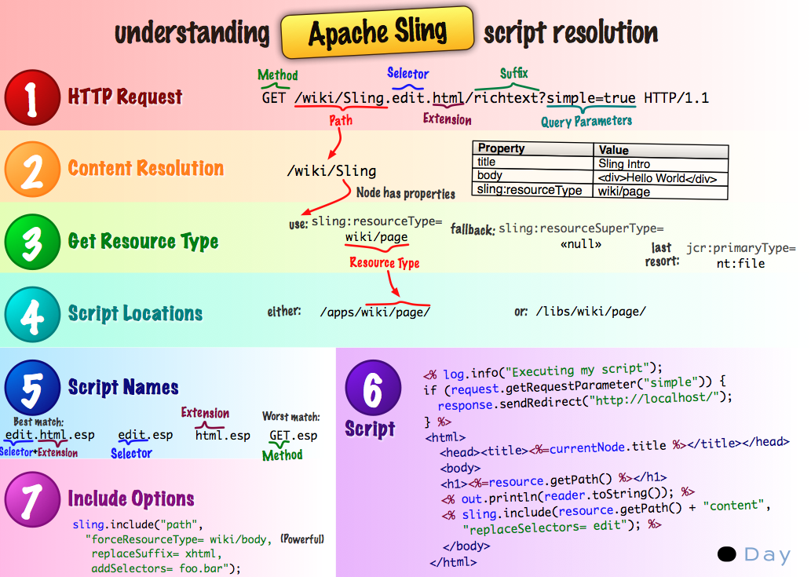

The following diagram explains all the hidden, but powerful, request parameters you can use when dealing with the SlingPostServlet, the default handler for all POST requests that gives you endless options for creating, modifying, deleting, copying and moving nodes in the repository.

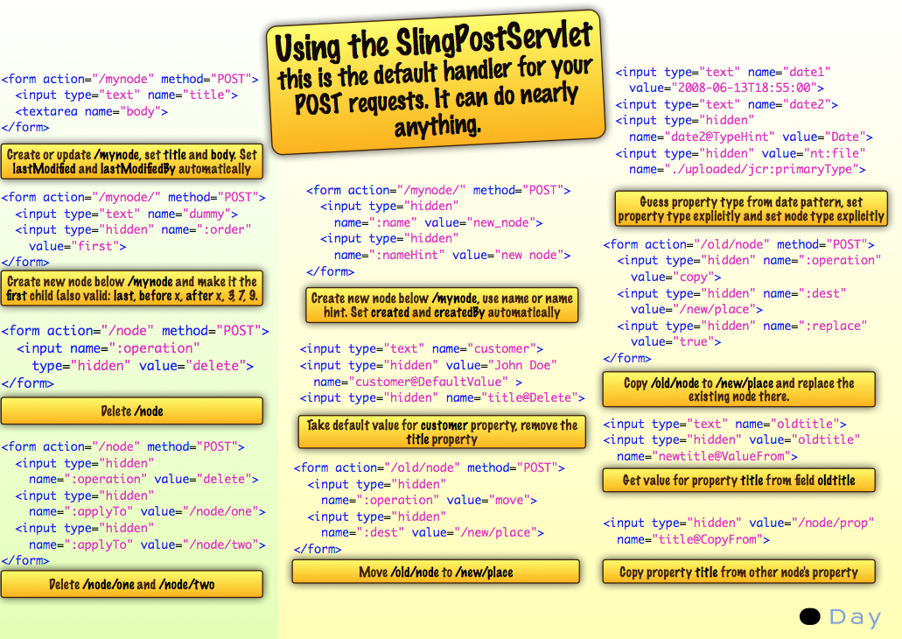

### 

### **Sling is Content Centric**

Sling is *content-centric*. This means that processing is focused on the content as each (HTTP) request is mapped onto content in the form of a JCR resource (a repository node):

* the first target is the resource (JCR node) holding the content
* secondly, the representation, or script, is located from the resource properties in combination with certain parts of the request (e.g. selectors and/or the extension)

### **RESTful Sling**

Due to the content-centric philosophy, Sling implements a REST-oriented server and thus features a new concept in web application frameworks. The advantages are:

* very RESTful, not just on the surface; resources and representations are correctly modelled inside the server
* removes one or more data models
  + previously the following were needed: URL structure, business objects, DB schema;
  + this is now reduced to: URL = resource = JCR structure

### 

### **URL Decomposition**

In Sling, processing is driven by the URL of the user request. This defines the content to be displayed by the appropriate scripts. To do this, information is extracted from the URL.

If we analyze the following URL:

|  |  |
| --- | --- |
|  | [**http://myhost/tools/spy.printable.a4.html/a/b?x=12**](http://myhost/tools/spy.printable.a4.html/a/b?x=12) |

We can break it down into its composite parts:

|  |  |  |  |  |  |  |  |  |
| --- | --- | --- | --- | --- | --- | --- | --- | --- |
| protocol | host | content path | selector(s) | extension |  | suffix |  | param(s) |
| http:// | myhost | tools/spy | .printable.a4. | html | / | a/b | ? | x=12 |

**protocol**

HTTP

**host**

Name of the website.

**content path**

Path specifying the content to be rendered. Is used in combination with the extension; in this example they translate to tools/spy.html.

**selector(s)**

Used for alternative methods of rendering the content; in this example a printer-friendly version in A4 format.

**extension**

Content format; also specifies the script to be used for rendering.

**suffix**

Can be used to specify additional information.

**param(s)**

Any parameters required for dynamic content.

#### From URL to Content and Scripts

Using these principles:

* the mapping uses the content path extracted from the request to locate the resource
* when the appropriate resource is located, the sling resource type is extracted, and used to locate the script to be used for rendering the content

The figure below illustrates the mechanism used, which will be discussed in more detail in the following sections.

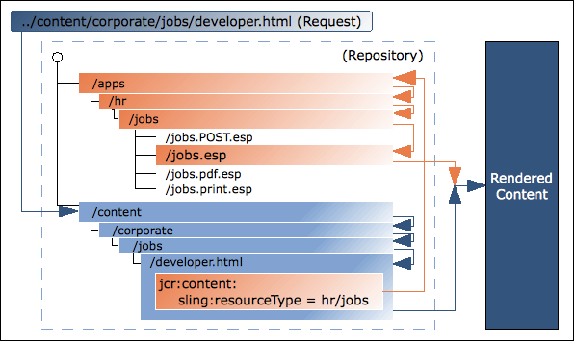

With Sling, you specify which script renders a certain entity (by setting the sling:resourceType property in the JCR node). This mechanism offers more freedom than one in which the script accesses the data entities (as an SQL statement in a PHP script would do) as a resource can have several renditions.

#### Mapping requests to resources

The request is broken down and the necessary information extracted. The repository is searched for the requested resource (content node):

* first Sling checks whether a node exists at the location specified in the request; e.g. ../content/corporate/jobs/developer.html
* if no node is found, the extension is dropped and the search repeated; e.g. ../content/corporate/jobs/developer
* if no node is found then Sling will return the http code 404 (Not Found).

Sling also allows things other than JCR nodes to be resources, but this is an advanced feature.

### **Locating the script**

When the appropriate resource (content node) is located, the **sling resource type** is extracted. This is a path, which locates the script to be used for rendering the content.

The path specified by the **sling:resourceType** can be either:

* absolute
* relative, to a configuration parameter  
  Relative paths are recommended by Adobe as they increase portability.

All Sling scripts are stored in subfolders of either **/apps** or **/libs**, which will be searched in this order (see [Customizing Components and Other Elements](https://helpx.adobe.com/experience-manager/6-3/sites/developing/using/dev-guidelines-bestpractices.html#CustomizingComponentsandOtherElements)).

A few other points to note are:

* when the Method (GET, POST) is required, it will be specified in uppercase as according to the HTTP specification e.g. jobs.POST.esp (see below)
* various script engines are supported:
  + **.esp, .ecma**: ECMAScript (JavaScript) Pages (server-side execution)
  + **.jsp**: Java Server Pages (server-side execution)
  + **.java**: Java Servlet Compiler (server-side execution)
  + **.jst**: JavaScript templates (client-side execution)

The list of script engines supported by the given instance of CQ are listed on the Felix Management Console (**http://localhost:4502/system/console/config/slingscripting.txt**).

Additionally, Apache Sling supports integration with other popular scripting engines (e.g., Groovy, JRuby, Freemarker), and provides a way of integrating new scripting engines.

Using the above example, if the **sling:resourceType** is **hr/jobs** then for:

* GET/HEAD requests, and URLs ending in .html (default request types, default format)  
  The script will be /apps/hr/jobs/jobs.esp; the last section of the sling:resourceType forms the file name.
* POST requests (all request types excluding GET/HEAD, the method name must be uppercase)  
  POST will be used in the script name.  
  The script will be **/apps/hr/jobs/jobs.POST.esp**.
* URLs in other formats, not ending with .html  
  For example **../content/corporate/jobs/developer.pdf**  
  The script will be **/apps/hr/jobs/jobs.pdf.esp**; the suffix is added to the script name.
* URLs with selectors  
  Selectors can be used to display the same content in an alternative format. For example a printer friendly version, an rss feed or a summary.  
  If we look at a printer friendly version where the selector could be *print*; as in **../content/corporate/jobs/developer.print.html**  
  The script will be **/apps/hr/jobs/jobs.print.esp**; the selector is added to the script name.
* If no sling:resourceType has been defined then:
  + the content path will be used to search for an appropriate script (if the path based ResourceTypeProvider is active).  
    For example, the script for **../content/corporate/jobs/developer.html** would generate a search in **/apps/content/corporate/jobs/**.
  + the primary node type will be used.
* If no script is found at all then the default script will be used.  
  The default rendition is currently supported as plain text (.txt), HTML (.html) and JSON (.json), all of which will list the node's properties (suitably formatted). The default rendition for the extension .res, or requests without a request extension, is to spool the resource (where possible).
* For http error handling (codes 403 or 404) Sling will look for a script at either:
  + the location /apps/sling/servlet/errorhandler for [customized scripts](https://helpx.adobe.com/experience-manager/6-3/sites/developing/using/customizing-errorhandler-pages.html)
  + or the location of the standard scripts /libs/sling/servlet/errorhandler/403.esp, or 404.esp respectively.

If multiple scripts apply for a given request, the script with the best match is selected. The more specific a match is, the better it is; in other words, the more selector matches the better, regardless of any request extension or method name match.

For example, consider a request to access the resource  
    **/content/corporate/jobs/developer.print.a4.html**   
of type   
    **sling:resourceType="hr/jobs"**

Assuming we have the following list of scripts in the correct location:

1. **GET.esp**
2. **jobs.esp**
3. **html.esp**
4. **print.esp**
5. **print.html.esp**
6. **print/a4.esp**
7. **print/a4/html.esp**
8. **print/a4.html.esp**

Then the order of preference would be (8) - (7) - (6) - (5) - (4) - (3) - (2) - (1).

In addition to the resource types (primarily defined by the **sling:resourceType** property) there is also the resource super type. This is generally indicated by the **sling:resourceSuperType** property. These super types are also considered when trying to find a script. The advantage of resource super types is that they may form a hierarchy of resources where the default resource type **sling/servlet/default** (used by the default servlets) is effectively the root.

The resource super type of a resource may be defined in two ways:

* by the **sling:resourceSuperType** property of the resource.
* by the **sling:resourceSuperType** property of the node to which the **sling:resourceType** points.

For example:

* /
  + a
  + b
    - sling:resourceSuperType = a
  + c
    - sling:resourceSuperType = b
  + x
    - sling:resourceType = c
  + y
    - sling:resourceType = c
    - sling:resourceSuperType = a

The type hierarchy of /x is [ c, b, a, <default>] while for /y the hierarchy is [ c, a, <default>] because /y has the **sling:resourceSuperType** property whereas /x does not and therefore its supertype is taken from its resource type.

#### **Sling Scripts cannot be called directly**

Within Sling, scripts cannot be called directly as this would break the strict concept of a REST server; you would mix resources and representations.

If you call the representation (the script) directly you hide the resource inside your script, so the framework (Sling) no longer knows about it. Thus you lose certain features:

* automatic handling of http methods other than GET, including:
  + POST, PUT, DELETE which are handled with a sling default implementation
  + the POST.jsp script in your sling:resourceType location
* your code architecture is no longer as clean nor as clearly structured as it should be; of prime importance for large-scale development

### 

### **Sling API**

This uses the Sling API package, org.apache.sling.*, and tag libraries.

### Referencing existing elements using sling:include

A final consideration is the need to reference existing elements within the scripts.

More complex scripts (aggregating scripts) might need to access multiple resources (for example navigation, sidebar, footer, elements of a list) and do so by including the *resource*.

To do this you can use the sling:include("/<path>/<resource>") command. This will effectively include the definition of the referenced resource, as in the following statement which references an existing definition for rendering images:

|  |  |
| --- | --- |
|  | **%><sling:include resourceType="geometrixx/components/image/img"/><%** |

## OSGI

OSGi defines an architecture for developing and deploying modular applications and libraries (it is also known as the Dynamic Module System for Java). OSGi containers allow you to break your application into individual modules (are jar files with additional meta information and called bundles in OSGi terminology) and manage the cross-dependencies between them with:

* services implemented within the container
* a contract between the container and your application

These services and contracts provide an architecture which enables individual elements to dynamically discover each other for collaboration.

An OSGi framework then offers you dynamic loading/unloading, configuration and control of these bundles - without requiring restarts.

**Note:**

Full information on OSGi technology can be found at the [OSGi Alliance Technology Overview](http://www.osgi.org/About/Technology).

In particular, their Basic Education page holds a collection of presentations and tutorials.

This architecture allows you to extend Sling with application specific modules. Sling, and therefore CQ5, uses the Apache Feliximplementation of OSGI (Open Services Gateway initiative) and is based on the OSGi Service Platform Release 4 Version 4.2 Specifications. They are both collections of OSGi bundles running within an OSGi framework.

This enables you to perform the following actions on any of the packages within your installation:

* install
* start
* stop
* update
* uninstall
* see the current status
* access more detailed information (e.g. symbolic name, version, location, etc) about the specific bundles

See the Web Console, [OSGI Configuration](https://helpx.adobe.com/experience-manager/6-3/sites/deploying/using/configuring-osgi.html) and [OSGi Configuration Settings](https://helpx.adobe.com/experience-manager/6-3/sites/deploying/using/osgi-configuration-settings.html) for more information.

## Development Objects in the AEM Environment

The following are of interest for development:

**Item**

An item is either a node or a property.

For detailed information on manipulating Item objects, refer to the [Javadocs](http://www.day.com/maven/javax.jcr/javadocs/jcr-2.0/javax/jcr/Item.html) of the Interface javax.jcr.Item

**Node (and their properties)**

Nodes and their properties are defined in the [JCR API 2.0 specification (JSR 283)](http://www.day.com/specs/jcr/2.0/3_Repository_Model.html#3.1.2%20Items). They store content, object definitions, rendering scripts and other data.

Nodes define the content structure, and their properties store the actual content and metadata.

Content nodes drive the rendering. Sling gets the content node from the incoming request. The property sling:resourceType of this node points to the Sling rendering component to be used.

A node, which is a JCR name, is also called a resource in the Sling environment.

For example, to get the properties of the current node, you can use following code in your script:

**PropertyIterator properties = currentNode.getProperties();**

With currentNode being the current node object.

For more information on manipulating Node objects, refer to the [Javadocs](http://www.day.com/maven/javax.jcr/javadocs/jcr-2.0/javax/jcr/Node.html).

**Widget**

In AEM all user input is managed by widgets. These are often used to control the editing of a piece of content.

Dialogs are built by combining Widgets.

AEM has been developed using the ExtJS library of widgets.

**Dialog**

A dialog is a special type of widget.

To edit content, AEM uses dialogs defined by the application developer. These combine a series of widgets to present the user with all fields and actions necessary to edit the related content.

 Dialogs are also used for editing metadata, and by various administrative tools.

**Component**

A software component is a system element offering a predefined service or event, and able to communicate with other components.

Within AEM a component is often used to render the content of a resource. When the resource is a page, the component rendering it is called a Top-Level Component or a Pagecomponent. However, a component does not have to render content, nor be linked to a specific resource; for example, a navigation component will display information about multiple resources.

The definition of a component includes:

* the code used to render the content
* a dialog for the user input and the configuration of the resulting content.

**Template**

A template is the base for a specific type of page. When creating a page in the Websites tab the user has to select a template. The new page is then created by copying this template.

A template is a hierarchy of nodes that has the same structure as the page to be created, but without any actual content.

It defines the page component used to render the page and the default content (primary top-level content). The content defines how it is rendered as AEM is content-centric.

**Page Component (Top-Level Component)**

The component to be used to render the page.

**Page**

A page is an 'instance' of a template.

A page has a hierarchy node of type cq:Page and a content node of type cq:PageContent. The property sling:resourceType of the content node points to the Page Component used for rendering the page.

For example, to get the name of the current page, you can use following code in your script:

String pageName = currentPage.getName();

With currentPage being the current page object. For more information on manipulating Page objects, refer to the [Javadocs](https://helpx.adobe.com/experience-manager/6-3/sites/developing/using/reference-materials/javadoc/com/day/cq/wcm/api/Page.html).

**Page Manager**

The page manager is an Interface that provides methods for page level operations.

 For example, to get the containing page of a resource, you can use following code in your script:

 Page myPage = pageManager.getContainingPage(myResource);

 With pageManager being the page manager object and myResource a resource object. For more information on the methods provided by the page manager, refer to the [Javadocs](https://helpx.adobe.com/experience-manager/6-3/sites/developing/using/reference-materials/javadoc/com/day/cq/wcm/api/PageManager.html).

## Structure within the Repository

The following list gives an overview of the structure you will see within the repository.

**Caution:**

Changes to this structure, or the files within it, should be made with care.

Changes are needed when you are developing, but you should take care that you fully understand the implications of any changes you make.

**Caution:**

You must not change anything in the **/libs** path. For configuration and other changes copy the item from **/libs** to **/apps** and make any changes within **/apps**.

* **/apps**  
  Application related; includes component definitions specific to your website. The components that you develop can be based on the out of the box components available at **/libs/foundation/components**.
* **/content**  
  Content created for your website.
* **/etc**  
  [Tools section](https://helpx.adobe.com/experience-manager/6-3/sites/administering/using/tools-consoles.html) for detailed information.
* **/home**  
  User and Group information.
* **/libs**  
  Libraries and definitions that belong to the core of AEM. The sub-folders in **/libs** represent the out of the box AEM features as for example search or replication.  The content in **/libs** should not be modified as it affects the way AEM works. Features specific to your website should be developed under **/apps** (see [Customizing Components and Other Elements](https://helpx.adobe.com/experience-manager/6-3/sites/developing/using/dev-guidelines-bestpractices.html#CustomizingComponentsandOtherElements)).
* **/tmp**  
  Temporary working area.
* **/var**  
  Files that change and are updated by the system; such as audit logs, statistics, event-handling. The sub-folder **/var/classes** contains the java servlets in source and compiled forms that have been generated from the components scripts.

## Environments

With AEM a production environment often consists of two different types of instances: an [Author and a Publish instances](https://helpx.adobe.com/experience-manager/6-3/sites/deploying/using/deploy.html#AuthorandPublishInstalls).

## The Dispatcher

The Dispatcher is Adobe's tool for both caching and/or load balancing. Further information can be found under [the Dispatcher](https://helpx.adobe.com/experience-manager/dispatcher/user-guide.html).

## FileVault (source revision system)

FileVault provides your JCR repository with file system mapping and version control. It can be used to manage AEM development projects with full support for storing and versioning project code, content, configurations and so on, in standard version control systems (for example, Subversion).

See the [FileVault tool](https://helpx.adobe.com/experience-manager/6-3/sites/developing/using/ht-vlttool.html) documentation for detailed information.

## Workflows

Your content is often subject to organizational processes, including steps such as approval and sign-off by various participants. These processes can be represented as workflows, [defined and developed within AEM](https://helpx.adobe.com/experience-manager/6-3/sites/developing/using/workflows-models.html), then applied to the [appropriate content pages](https://helpx.adobe.com/experience-manager/6-3/sites/administering/using/workflows.html) or [digital assets](https://helpx.adobe.com/experience-manager/6-3/assets/using/assets-workflow.html) as required.

The Workflow Engine is used to manage the implementation of your workflows, and their subsequent application to your content.

## Multi-Site Management

Multi Site Manager (MSM) enables you to easily manage multiple web sites that share common content. MSM lets you define relations between the sites so that content changes in one site are automatically replicated in other sites.

For example, web sites are often provided in multiple languages for international audiences. When the number of sites in the same language is low (three to five), a manual process for syncronizing content across sites is possible. However, as soon as the number of sites grows or when multiple languages are involved, it becomes more efficient to automate the process.

* Efficiently manage different language versions of a website.
* Automatically update one or more sites based on a source site:
  + Enforce a common base structure and use common content across multiple sites.
  + Maximize the use of available resources.
  + Maintain a common look and feel.
  + Focus efforts on managing the content that differs between the sites.

**Customizing Pages shown by Error Handler**

CQ comes with a standard error handler for handling HTTP errors; for example, by showing:

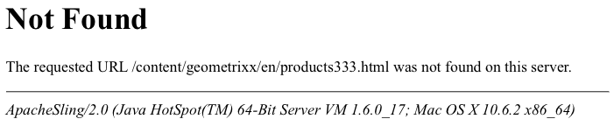

System provided scripts exist (under **/libs/sling/servlet/errorhandler**) to respond to error codes, by default the following are available with a standard CQ instance:

* 403.jsp
* 404.jsp

**Note:**

CQ is based on Apache Sling, so see <http://sling.apache.org/site/errorhandling.html> for detailed information about Sling Error Handling.

**Note:**

On an author instance, [CQ WCM Debug Filter](https://helpx.adobe.com/experience-manager/6-3/sites/deploying/using/osgi-configuration-settings.html#DayCQWCMDebugFilter) is enabled by default. This always results in the response code 200. The default error handler responds by writing the full stack trace to the response.

On a publish instance, CQ WCM Debug Filter is *always* disabled (even if configured as enabled).

### **How to Customize Pages shown by the Error Handler**

You can develop your own scripts to customize the pages shown by the error handler when an error is encountered. Your customized pages will be created under **/apps** and overlay the default pages (that are under **/libs**).

**Note:**

See [Using Overlays](https://helpx.adobe.com/experience-manager/6-3/sites/developing/using/overlays.html) for more details.

1. In the repository, copy the default script(s):
   * from **/libs/sling/servlet/errorhandler/**
   * to **/apps/sling/servlet/errorhandler/**

As the destination path does not exist by default you will need to create it when doing this for the first time.

1. Navigate to **/apps/sling/servlet/errorhandler**. Here you can either:
   * edit the appropriate existing script to supply the information required.
   * create, and edit, a new script for the required code.
2. Save the changes and test.

**Caution:**

The 404.jsp and 403.jsp handlers have been specifically designed to cater for CQ5 authentication; in particular, to allow for system login in the case of these errors.

Therefore, replacement of these two handlers should be done with great care.

### Customizing the Response to HTTP 500 Errors

HTTP 500 errors are caused by server side exceptions.

* [**500 Internal Server Error**](http://www.w3.org/Protocols/rfc2616/rfc2616-sec10.html)  
  The server encountered an unexpected condition which prevented it from fulfilling the request.

When request processing results in an exception, the Apache Sling framework (that CQ is built on):

* logs the exception
* returns:
  + the HTTP response code 500
  + the exception stack trace

in the body of the response.

By [customizing the pages shown by the error handler](https://helpx.adobe.com/experience-manager/6-3/sites/developing/using/customizing-errorhandler-pages.html#CustomizingthePagesshownbytheErrorHandler) a **500.jsp** script can be created. However, it is only used if **HttpServletResponse.sendError(500)** is executed explicitly; i.e. from an exception catcher.

Otherwise, the response code is set to 500, but the **500.jsp** script is not executed.

To handle 500 errors, the file name of the error handler script must be the same as the exception class (or superclass). To handle all such exceptions you can create a script **/apps/sling/servlet/errorhandler/Throwable.js**p or **/apps/sling/servlet/errorhandler/Exception.jsp**.

**Caution:**

On an author instance, [CQ WCM Debug Filter](https://helpx.adobe.com/experience-manager/6-3/sites/deploying/using/osgi-configuration-settings.html#DayCQWCMDebugFilter) is enabled by default. This always results in the response code 200. The default error handler responds by writing the full stack trace to the response.

For a custom error-handler, responses with code 500 are needed - so the [CQ WCM Debug Filter needs to be disabled](https://helpx.adobe.com/experience-manager/6-3/sites/deploying/using/osgi-configuration-settings.html#DayCQWCMDebugFilter). This ensures that the response code 500 is returned, which in turn triggers the correct Sling error-handler.

On a publish instance, CQ WCM Debug Filter is *always* disabled (even if configured as enabled).

## Guidelines for Using Templates and Components

AEM components and templates form a very powerful toolkit. They can be used by developers to provide website business users, editors, and administrators with the functionality to adapt their websites to changing business needs (content agility) while retaining the uniform layout of the sites (brand protection).

A typical challenge for a person responsible for a website, or set of websites (for example in a branch office of a global enterprise), is to introduce a new type of content presentation on their websites.

Let us assume there is a need to add a newslist page to the websites, which lists extracts from other articles already published. The page should have the same design and structure as the rest of the website.

The recommended way to approach such a challenge would be to:

* Reuse an existing template to create a new type of page. The template roughly defines page structure (navigation elements, panels, and so on), which is further fine-tuned by its design (CSS, graphics).
* Use the paragraph system (parsys/iparsys) on the new pages.
* Define access right to the Design mode of the paragraph systems, so that only authorized people (usually the administrator) can change them.
* Define the components allowed in the given paragraph system so that editors can then place the required components on the page. In our case it could be a list component, which can traverse a subtree of pages and extract the information according to predefined rules.
* Editors add and configure the allowed components, on the pages they are responsible for, to deliver the requested functionality (information) to the business.

This illustrates how this approach empowers the contributing users and administrators of the website to respond to business needs quickly, without requiring the involvement of development teams. Alternative methods, such as creating a new template, is usually a costly exercise, requiring a change management process and involvement of the development team. This makes the whole process much longer and costly.

The developers of AEM-based systems should therefore use:

* templates and access control to paragraph system design for uniformity and brand protection
* paragraph system including its configuration options for flexibility.

The following general rules for developers make sense in majority of usual projects:

* Keep the number of templates low - as low as the number of fundamentally different page structures on the web sites.
* Provide necessary flexibility and configuration capabilities to your custom components.
* Maximize use of the power and flexibility of AEM paragraph system - the parsys & iparsys components.

#### **Customizing Components and Other Elements**

When creating your own components or customizing an existing component it is often easiest (and safest) to re-use existing definitions. The same principles also applies to other elements within AEM, for example the error handler.

This can be done by copying and overlaying the existing definition. In other words, copying the definition from **/libs** to **/apps/<your-project>**. This new definition, in **/apps**, can be updated according to your requirements.

**Note:**

See [Using Overlays](https://helpx.adobe.com/experience-manager/6-3/sites/developing/using/overlays.html) for more details.

For example:

* [Customizing a Component](https://helpx.adobe.com/experience-manager/6-3/sites/developing/using/components.html)  
  This involved overlaying a component definition:
  + Create a new component folder in **/apps/<website-name>/components/<MyComponent>** by copying an existing component:
    - For example, to customize the Text component copy:
      * from **/libs/foundation/components/text**
      * to **/apps/myProject/components/text**
* [Customizing pages shown by the Error Handler](https://helpx.adobe.com/experience-manager/6-3/sites/developing/using/customizing-errorhandler-pages.html#HowtoCustomizePagesshownbytheErrorHandler)  
  This case involves overlaying a servlet:  
  + In the repository, copy the default script(s):
    - from **/libs/sling/servlet/errorhandler/**
    - to **/apps/sling/servlet/errorhandler/**

**Caution:**

You **must not** change anything in the **/libs** path.

This is because the content of **/libs** is overwritten the next time you upgrade your instance (and may well be overwritten when you apply either a hotfix or feature pack).

For configuration and other changes:

1. copy the item in **/libs** to **/apps**
2. make any changes within **/apps**

## When to use JCR Queries and when not to use them

JCR Queries are a powerful tool when employed correctly. They are appropriate for:

* real end-user queries, such as fulltext searches on content.
* occasions where structured content needs to be found across the entire repository.   
    
  In such cases, make sure that queries only run when absolutely required, e.g. on component activation or cache invalidation (as opposed to e.g. Workflows Steps, Event Handlers that trigger on content modifications, Filters, etc).

JCR Queries should never be used for pure rendering requests. For example, JCR Queries are not appropriate for

* rendering navigation
* creating a "top 10 latest news items" overview
* showing counts of content items

For rendering content, use navigational access to the content tree instead of performing a JCR Query.

**Note:**

If you use the [Query Builder](https://helpx.adobe.com/experience-manager/6-3/sites/developing/using/querybuilder-api.html), you use JCR Queries, as the Query Builder generates JCR Queries under the hood.

## Security Considerations

**Note:**

It is also worthwhile referencing the [security checklist](https://helpx.adobe.com/experience-manager/6-3/sites/administering/using/security-checklist.html).

### JCR (Repository) Sessions

You should use the user session, not the administrative session. This means you should use:

|  |  |
| --- | --- |
|  | **slingRequest.getResourceResolver().adaptTo(Session.class);** |

### **Protect against Cross-Site Scripting (XSS)**

Cross-site scripting (XSS) allows attackers to inject code into web pages viewed by other users. This security vulnerability can be exploited by malicious web users to bypass access controls.

AEM applies the principle of filtering all user-supplied content upon output. Preventing XSS is given the highest priority during both development and testing.

Additionally, a web application firewall, such as [mod_security for Apache](http://www.modsecurity.org/projects/modsecurity/apache/), can provide reliable, central control over the security of the deployment environment and protect against previously undetected cross-site scripting attacks.

**Caution:**

Example code provided with AEM may not itself protect against such attacks and generally relies on request filtering by a web application firewall.

The XSS API cheat sheet contains information you need to know in order to use the XSS API and make an AEM app more secure. You can download it here:

**DOWNLOAD**

[**Get file**](https://helpx.adobe.com/content/dam/help/en/experience-manager/6-3/sites/developing/using/dev-guidelines-bestpractices/_jcr_content/main-pars/download-section/download-1/xss_cheat_sheet_2016.pdf)

The XSSAPI cheat sheet.

### Securing Communication for Confidential Information

As for any internet application, make sure that when transporting confidential information

* traffic is secured through SSL
* HTTP POST is used if applicable

This applies to information that is confidential to the system (like configuration or administrative access) as well as information confidential to its users (like their personal details)

## Distinct Development Tasks

### Customizing Error Pages

Error pages can be customized for AEM. This is advisable so that the instance does not reveal sling traces on internal server errors.

See [Customizing Error Pages shown by the Error Handler](https://helpx.adobe.com/experience-manager/6-3/sites/developing/using/customizing-errorhandler-pages.html) for full details.

### **Open Files in the Java Process**

Because AEM can access a large number of files it is recommended that the number of [open files for a Java process](https://helpx.adobe.com/experience-manager/6-3/sites/deploying/using/configuring.html#OpenFIlesintheJavaProcess) be explicitly configured for AEM.

To minimize this issue development should ensure that any file opened is correctly closed as soon as (meaningfully) possible.